TRAVEL BLOG

# STEPS FOR DESIGN

Vacations often start off as a wonderful idea and then eventually end up being a nightmare to manage. Often overlooked, a lot of thought and brainstorming goes into perfectly organizing touring plans. The lack of know-how on how to plan a trip often reflects during “unseen hurdles” on a vacation.

With a little bit of preparation and effort in maintaining a personalized trip planner, travelers can overcome 90% of their difficulties they may face during a trip. Here are some handy trip planning tips that will keep your prepared for the proverbial rainy-day.

## 1. Pick your destination

It all probably emanates from either some stunning pics gone viral on social media, the scenic setting of a movie, or an irresistible story of a friend’s last trip abroad. Touring plans, more often than not, are triggered by external factors.

Things to keep in mind before selecting a destination

* There’s nothing to say when a traveler’s mind wishes to visit the beaches, mountains, or a forest. However, picking the right destination according to the season is a key factor in understanding how to plan a trip successfully.
* Check out the best time to visit all destinations. Usually, the ideal season to visit beaches and mountains is completely different.
* Consider the cost factor while picking a destination. Some places are more enjoyable in a luxury budget than others. Going to a luxury destination during the shoulder season (a few weeks before or after the official ‘busy season’) can result in some good discounts on hotels and flights.
* Safety of travelers is a prime concern people should address before starting on their journey (especially solo female travelers).
* Ease of accessibility or lack thereof is also a factor that can sway the decision of visiting a destination or not. Generally, the popular destinations have a lot of daily flights, trains, and good highway infrastructure to support the tourist influx.

## 2. Decide the duration of your trip

There is a fine line between getting bored and enjoying every moment at a destination. However, no destination has a predefined ideal duration. It often depends on the touring plans and purpose of the visit of the travelers. Some travelers like to see new cities every day, whereas some travelers prefer taking it slow by witnessing and enjoying the subtle nuances of places they visit. This is a key aspect of your **trip planning** which can help your itinerary and budget both.

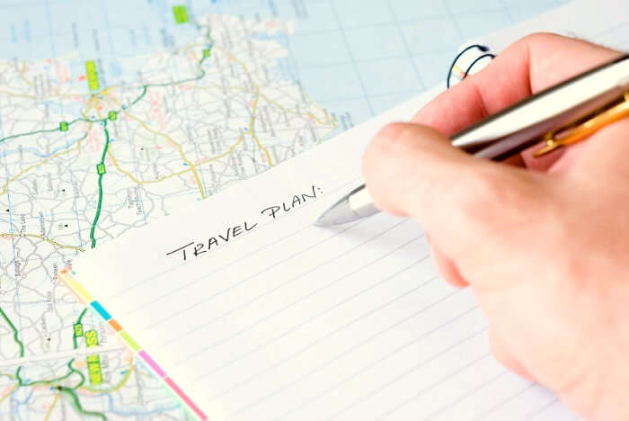

Things to keep in mind before deciding the duration of a trip

* A key aspect of a good trip planner is to correctly estimate the number of days required to visit a destination. A road trip planner would elongate the duration of a trip whereas, a trip planned with flight tickets could be a little shorter.
* Trips, where the destination is within 8 hours, can also be done on a weekend provided that the night time is utilized for traveling.
* A trip with a lot of urban destinations will need more time in the sightseeing, and therefore a longer trip duration. Whereas a trip to a tropical beach town would not involve much sightseeing and hence, the duration can be shorter.
* It is advisable to keep a vacant day in touring plans that exceed 7 days. This gives a buffer to things like flight/train delays, traffic jams, weather hold-ups, or a change-of-heart to extend one’s stay at a particular destination.

## 3. Book flights, train, or bus tickets, and accommodation

After the ideation is complete, booking tickets for your flight, train or bus transfer well in advance is an important step in learning how to plan your trip to perfection. Since flight and train tickets are subject to availability and prices rise over time, getting the bookings done a few months in advance will help you avoid additional costs on your initial budget. Whether you are planning to explore the [hidden places in Goa](https://traveltriangle.com/blog/hidden-places-in-goa/) or [savour the local flavour of Rajasthan](https://traveltriangle.com/blog/food-of-rajasthan/), advance booking can help you with a hassle-free journey.



### Things to keep in mind while booking transfers and accommodation

* Only book the cheaper non-refundable flight or train tickets if you are absolutely certain of your vacation plans. Otherwise, it is advisable to book refundable tickets if booking well-in-advance.
* Flight prices fluctuate a lot, keep a track on flight prices by using Google Flights Tracker.
* Expect a surge in prices of flights and accommodations if you are booking tickets for a vacation that falls during the peak season of that particular destination.
* Use credit cards that give frequent flyer miles and points on every rupee spent on booking flights and hotels to earn great rewards and cash-backs.

## 4. Plan the day-wise activities and course of action

It always sounds fascinating and adventurous when touring plans are made on a sudden impulse and gut feel. However, the downside of going on such trips is that there could be many days where the scheduling can go haywire because of everything being so last-minute.



### Things to keep in mind while planning day-wise activities

* Depending on the budget and time-at-disposal, getting a rough idea of what activities should be done on what day is a vital ingredient in understanding how to plan a trip perfectly.
* Transfers between destinations should be kept as much as possible during the evening/night. This will provide enough time for sightseeing and activities as most of them are only possible during the day-time.
* Most of the times, it is better to book activities like water sports, adventure sports, boat-rides, and safari rides at the destination itself to get a better price and some scope for bargaining.
* In the trip planner, keep only one or two activities in a day if the purpose of the trip is to relax and take it easy during the vacation.
* At some places, popular tourists activities like skiing, boating, scuba diving etc are closed during offseason. Check the availability of activities before going to the destination.

## 5. Pack diligently and make all the necessary adjustments

After the bookings are done, it is always advisable for your**trip planning** to pack your stuff keeping in mind the destination and the influence of external factors on it. The unpredictability of weather, socio-political scenario, or a festive season can adversely affect travel plans.  In order to avoid alteration of touring plans due to these scenarios, travelers should do a bit of research before starting their vacation.

### Things to keep in mind while packing for a vacation

* An extra shirt, sweater, pair of jeans, or jumper can always prove handy during trips where the weather is expected to be cold or rainy
* Things like sunscreen, lotion, or mosquito repellent sound like unnecessary items but they are very vital in preventing any skin-related disease
* As a part of cultural sensitivity and responsible tourism, travelers must research about the destination they are visiting. Reading about the do’s and don’ts is advisable in order to avoid

How To Create a Comprehensive Customer Journey

